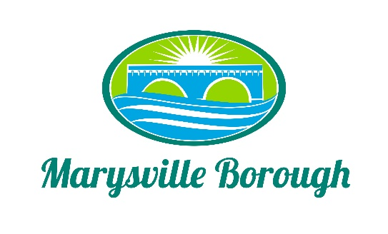

MS4 Meeting Minutes
April 4, 2022
5:00 PM

The MS4 Commission Meeting was called to order at 5:00 PM on Monday, April 4, 2022 at the Marysville Borough Office. Present were Commission Chair, Leigh Ann Urban, Commission members Charles Wentzel, Dave Magee and Terry Kline. Borough Manager, Zachary Border and Borough Engineer, Greg Rogalski were also present.

New Business
- Approve Minutes from the Previous Meeting
A motion was made by Charles and seconded by Terry to approve the minutes and the vote was unanimous.
- Locust Village Plan Overview
Greg presented an updated plan for the Locust Village drainage basin and informed the Commission that he was still waiting to hear back from Locust Village if they were okay to have an agreement in place that would allow the Borough to do the work and maintain the basin.
- Lions Club Updated Plan
Greg presented an update on the Lions Club Plan. One of the key changes was a floating dock in the pond which could be brought in each season. All of the discussion centered around the Recreation part of the plan. Terry then suggested a joint meeting between the Lions Club board and the MS4 Commission. The Commission decided that this meeting should happen at the MS4 Commission meeting in May. Terry will send out an email with the plan and an invite to the next meeting.
- Railroad Discussion
Greg had a discussion with the Solicitor from another municipality about how she negotiated with the railroad for them to pay their fair share of the Stormwater Fee. The municipality gave the railroad a bill and then negotiated a price they would pay from there. This was something Marysville could do as well but it would depend on the fee set up.
Old Business
- Status of Contract with Locust Village
This was discussed under New Business.
- Authority Status
Zach updated the Commission on the advice the Solicitor gave for the Authority. He suggested to start new since the old Authority would have expired. Zach also explained what the initial set up of the Authority would look like.
- Review of Last Month's Fee Structure Presentation - Commission's Thoughts?
The Commission continued discussion on the fee structure and what it would look like. The Commission recommend to Council a flat fee where the same fee would assess no matter the size of the property.

