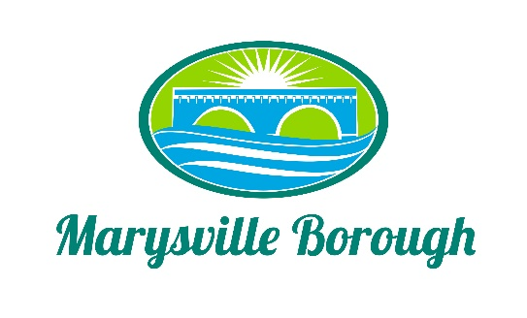

MS4 Meeting Minutes
May 2, 2022
5:00 PM

The MS4 Commission Meeting was called to order at 5:00 PM on Monday, May 2, 2022 at the Marysville Borough Office. Present were Commission members Charles Wentzel, Dave Magee and Terry Kline, Borough Manager, Zachary Border and Borough Engineer, Greg Rogalski.
New Business

- Approve Minutes from the Previous Meeting
The Minutes were reviewed and approved with no discussion.

- Lions Club Updated Plan
Members of the Lions Club Board were present to hear a presentation by Borough Engineer, Greg Rolgalski about the overall plan for improvements at the park for MS4 and Recreation. There were questions from the Board about the pond and how the pond would work with stormwater control.

