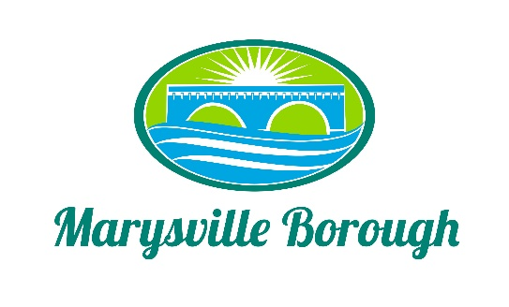

Streets Sewer and Sanitation Meeting Minutes
August 1, 2022
2:15 PM

The Streets, Sewer and Sanitation Committee meeting was called to order at 2:15 PM on Monday, August 1, 2022, at the Marysville Borough Office. Present were Committee Members Lance Barthel, John Edkin and Jackie Zulli, Committee Chair. Also present were Sewer Operators Lonnie Sarver and Pete Boele; Borough Engineer, Greg Rogalski and Borough Manager, Zachary Border.

New Business

- Review of Chapter 15 - Motor Vehicles and Traffic
During the last Council meeting, there was some confusion about the correct Ordinance that was being voted on, so Council decided to send the whole Ordinance back to the Committee to review. The Committee decided to eliminate the handicap parking on Lincoln Street and to make sure that under the section that talks about towing that the Resolution was updated to include companies that are included on the State Police Approved List.

- Policy for Sheriff Sale
At the last Council meeting, it was decided that anyone over two years of non-payment could be brought to sheriff sale. Lance wanted to add to that policy that anyone who starts the sheriff sale process cannot get out of it until the whole debt is paid off.

- Garbage Increase
Zach updated the increase in the garbage for the last year of the contract. The Committee suggested that Zach start right away on getting the new bids prepared for next year.

Old Business

- Pump Station 3
Greg talked about some different options presented for a grant idea for CDBG such a adding another wet well or adding a third pump. Greg also suggested writing a letter to all the residents connected to the pump station and acknowledge that their sump pump is hooked up to the sewer line but that the Borough will come in at its cost to hook them to the stormwater line. The Committee liked this idea but wanted to first see what happens with the grant.

- Sewer Billing
The Committee decided not to pursue water consumption any longer and remove this from the agenda.
Other Business
None.

Public Comment
Eber Morris, 101A Kings Highway, brought an issue to the Committee concerning the numbering of his house and how it gets confused with 101 Kings Highway as far as package delivery. He added that he is also concerned about emergency services noting that there was an emergency, emergency responders may go to the wrong house. The Committee decided that they wanted to affect the least number of houses possible. The suggestion was to turn 101A into 107A since they are right next door to each other in an effort to alleviate the confusion. The Committee asked Zach to look into the possibility of that happening.

Dave Magee commented on street signs in Rockville not having the directions labeled on the signs noting it is slowing down emergency services. The Committee asked Zach to reach out to John from Yingst to have that discussion.

